**Step 1: Create a presentation for the business managers**

Create visualizations of the most important findings from this Achievement in Tableau Public, then compile them into a presentation that tells a compelling story. Your presentation should include the following results:

* The results from step 2 of task 3.6
  + Summarize your data: Use SQL to calculate descriptive statistics for both the film table and the customer table. For numerical columns, this means finding the minimum, maximum, and average values. For non-numerical columns, calculate the mode value. Copy-paste your SQL queries and their outputs into your answers document.

**FILM**

select min(length) as min\_length,

max (length) as max\_length,

avg (length) as avg\_length,

min (rental\_duration) as min\_rent\_duration,

max (rental\_duration) as max\_rent\_duration,

avg (rental\_duration) as avg\_rent\_duration,

mode() within group (order by rating)

as modal\_value,

min (rental\_rate) as min\_rent\_rate,

max (rental\_rate) as max\_rent\_rate,

avg (rental\_rate) as avg\_rent\_rate,

count (rental\_rate) as count\_rent\_rate,

count (\*) as count\_rows

from film;

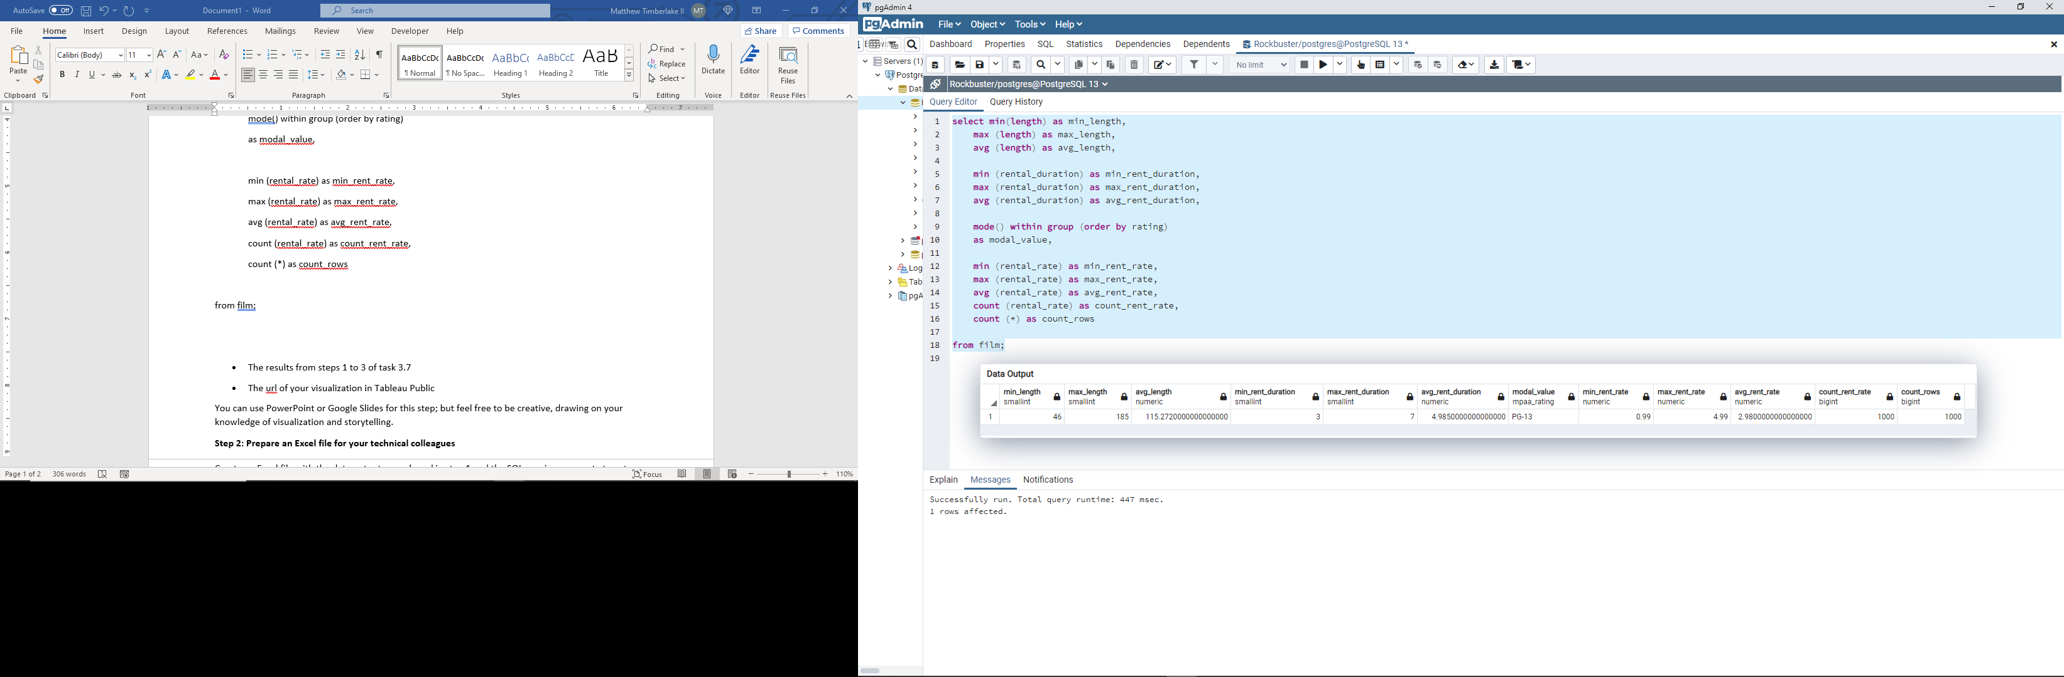

**CUSTOMER**

select

mode () within group (order by first\_name) as mode\_first\_name,

mode () within group (order by last\_name) as mode\_last\_name,

mode () within group (order by email) as mode\_email,

min (address\_id) as min\_address\_id,

max (address\_id) as max\_address\_id,

mode () within group (order by activebool) as mode\_active,

min (create\_date) as min\_create\_date,

max (create\_date) as max\_create\_date,

min (last\_update) as min\_last\_update,

max (last\_update) as max\_last\_update

from customer;

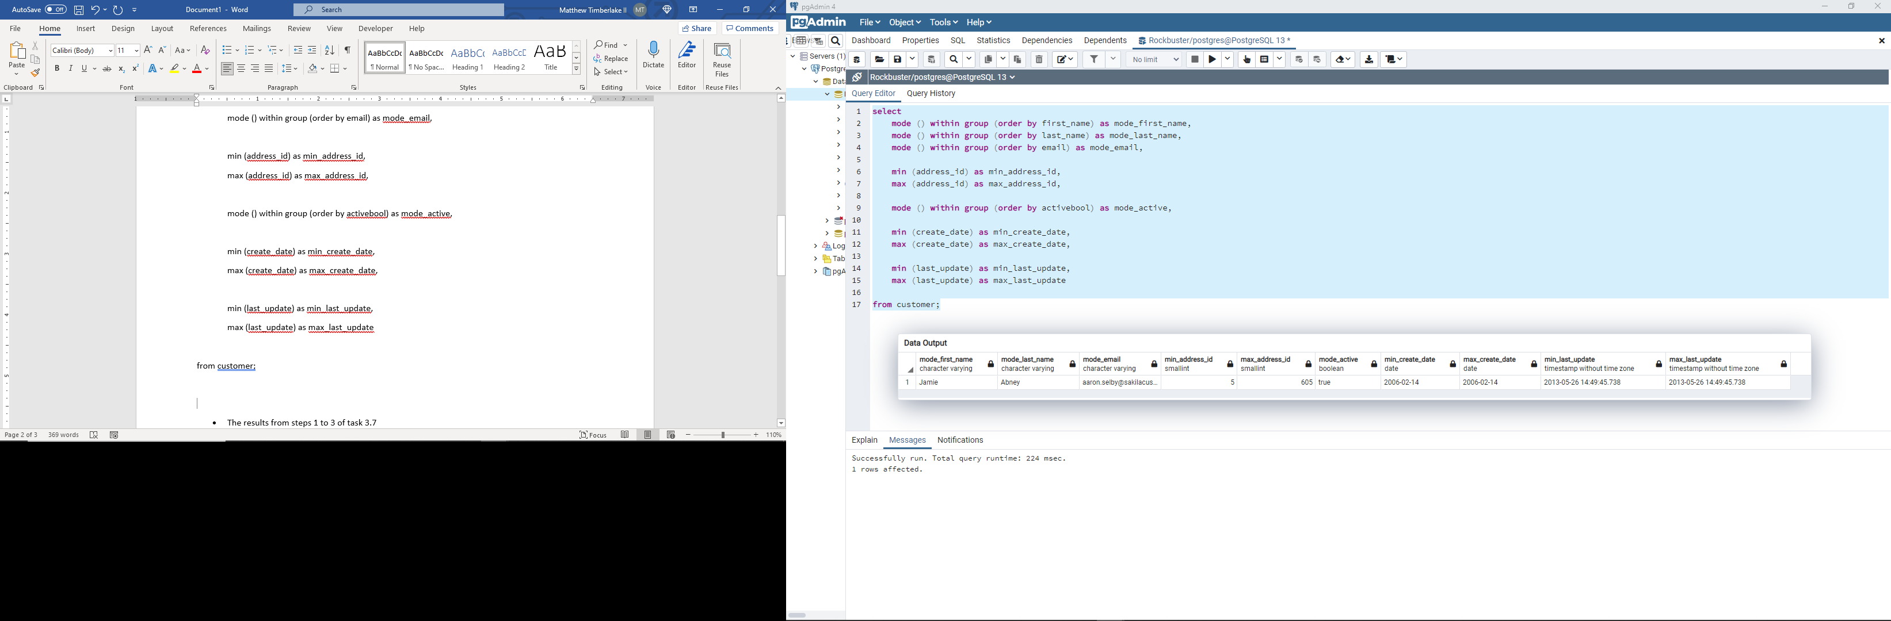

* The results from steps 1 to 3 of task 3.7
  + [Lesson\_3.7](file:///C:\Users\matth\OneDrive\Documents\Matthew\Coding%20Class\Career_Foundry%20Data%20Science%20Course\2.%20Data%20Immersion\Lesson%203\3.7%20Joining%20Tables%20of%20Data.docx)
* The url of your visualization in Tableau Public

You can use PowerPoint or Google Slides for this step; but feel free to be creative, drawing on your knowledge of visualization and storytelling.

**Step 2: Prepare an Excel file for your technical colleagues**

Create an Excel file with the data outputs you shared in step 1 and the SQL queries you wrote to get those results.

[Excel\_sheet\_film\_and\_customer](file:///C:\Users\matth\OneDrive\Documents\Matthew\Coding%20Class\Career_Foundry%20Data%20Science%20Course\2.%20Data%20Immersion\Lesson%203\FILM_and_CUSTOMER_summary.xlsx)

**Step 3: Finalize the data dictionary you drafted in Exercise 3.2**

Take another look at the [AdventureWorks data dictionary](https://dataedo.com/download/AdventureWorks.pdf" \t "_blank) to see what a professional data dictionary looks like. The tables on pages 9 and 10 will help you complete the fact/dimension tables in your dictionary.

Expand your dictionary by adding:

* A cover page (if you haven’t done so already)
* A table of contents
* Each fact/dimension table you’ve listed with a subsection, indicating the columns it links to
* Each fact/dimension table you’ve listed with a subsection, indicating the columns it links from
* Each fact/dimension table you’ve listed with a subsection, indicating the columns acting as unique keys
* Save your data dictionary as a PDF

**Step 4:**

Upload your presentation, Excel file, and data dictionary here for your mentor to review.